**Monthly Report**

Vineet Kumar Yadav, Research Scholar

NITT-CAIR, DRDO

June - 2022

**Objective-** Modelling of DC motor using transfer function and state space approach in different conditions with MATLAB codes and plots.

A) Motor without load and gear.

B) Motor with gear.

C) Motor directly coupled with load.

D) Motor coupled with load through gear.

**Introductions-:**

**Transfer function approach-**

The figure at the right represents a DC motor attached to an inertial load. The voltages applied to the field and armature sides of the motor are represented by ‘ $V_{f}$’and ‘ $V_{a}$’. The resistances and inductances of the field and armature sides of the motor are represented by ‘ $R_{f}$’, ‘ $L_{f}$’, ‘ $R_{a}$’, and ‘ $L_{a}$’. The torque generated by the motor is proportional to ‘ $I_{f}$’ and ‘ $I_{a}$’the currents in the field and armature sides of the motor,

$T_{m}= Ki_{f}i_{a}$ (1.1)

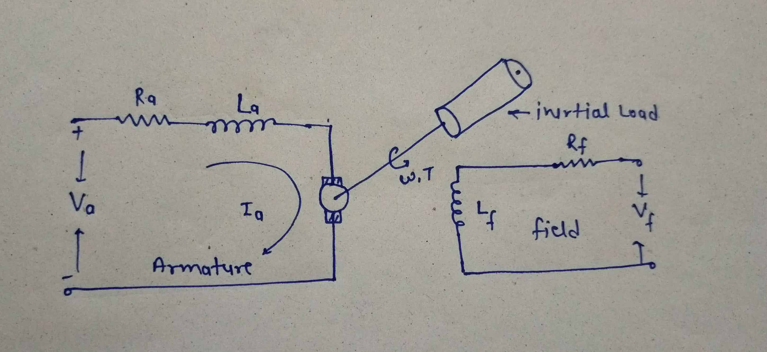

Figure 1. DC Motor

1. **Field-Current Controlled:**

In a field-current controlled motor, the armature current ‘ $i_{a}$’ is held constant, and the field current is controlled through the field voltage ‘ $V_{f}$’. In this case, the motor torque increases linearly with the field current. We write

$T_{m}= {K_{mf}i}_{f}$ (1.2)

Taking Laplace equation and rearranging the equation (2) become as follows

$K_{mf}=\frac{T_{m}(s)}{I_{f}(s)}$ (1.3)

For the field side of the motor the voltage/current relationship is

$V_{f}=V_{R}+V_{L}$ (1.4)

$$V_{f}=R_{f}i_{f}+L_{f}\frac{{di}_{f}}{dt}$$

The transfer function from the input voltage to the resulting current is found by taking Laplace transforms of both sides of this equation.

$\frac{I_{f}(s)}{V_{f}(s)}= \frac{\left(1/{L_{f}}\right)}{ s+\left({R_{f}}/{L_{f}}\right)}$ (1.5)

The transfer function from the input voltage to the resulting motor torque is found by combining the equations (1.2) and (1.5).

$\frac{T_{m}(s)}{V_{f}(s)}=\frac{T_{m}(s)}{I_{f}(s)}$ $\frac{ I_{f}(s)}{V_{f}(s)}$* = $\frac{\left({K_{mf}}/{L_{f}}\right)}{ s+\left({R_{f}}/{L_{f}}\right)}$ (1.6)

Equation (1.6) called first order DC motor system equation.

If, a step input in field voltage results in an exponential rise in the motor torque. An equation that describes the rotational motion of the inertial load is found by summing moments.

$J\dot{ω}+cω=T_{m}$ (1.7)

Taking Laplace on both side then we get,

$\frac{ω(s)}{T_{m}(s)}=\frac{\left(1/J\right)}{ s+\left(c/J\right)}$ (1.8)

From combining the equation (1.6) and (1.8) we get the transfer function from the input field voltage to the resulting speed change which is shown below

$\frac{ω\left(s\right)}{V_{f}\left(s\right)}=\frac{ω\left(s\right)}{T_{m}\left(s\right)}*\frac{T_{m}\left(s\right)}{V_{f}\left(s\right)}=\frac{\left({K_{mf}}/{JL_{f}}\right)}{\left( s+\left({R_{f}}/{L_{f}}\right)\right) \left( s+\left(c/J\right)\right)}$ (1.9)

Equation (1.9) called as the 2nd order DC motor system equation.

1. **Armature- current controlled-**

In an armature-current controlled motor, the field current ‘ $i_{f}$’is held constant, and the armature current is controlled through the armature voltage ‘ $V_{a}$’. In this case, the motor torque increases linearly with the armature current. We write,

$T_{m}= {K_{ma}i}_{a}$ (2)

The transfer function from the input armature current to the resulting motor torque is

$K_{ma}=\frac{T_{m}(s)}{I_{a}(s)}$ (2.1)

The voltage/current relationship for the armature side of the motor is

$V_{a}=V_{R}+V_{L}+V_{b}$ (2.2)

where ‘ $V_{b}$’ represents the "back EMF" induced by the rotation of the armature windings in a magnetic field. The back EMF ‘ $V_{b}$’ is proportional to the speed ‘ $ω$’, i.e.

‘ $V_{b}$’ = $K_{b}ω(s)$ (2.3)

Rewriting the equation, no (2.2) we get,

$V_{a}\left(s\right)-V_{b}(s)={(R}_{a}+L_{a}s)I_{a}(s)$ (2.4)

Substituting the ‘ $V_{b}$’ in the equation (2.4) then equation (2.4) become

$$V_{a}\left(s\right)- K_{b}ω(s)={(R}_{a}+L_{a}s)I_{a}(s)$$

As before, in the equation (1.8) the transfer function from the input motor torque to rotational speed changes is shown taking this in to consideration and draw the close loop feed block diagram as bellows.

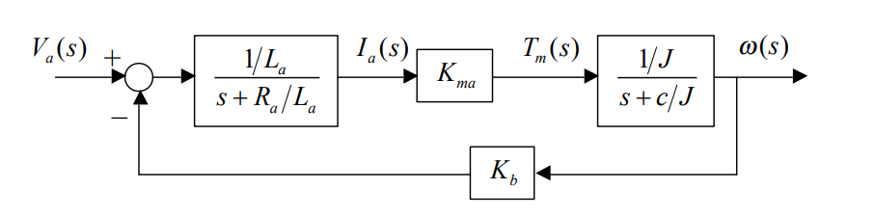

Figure .2 close loop feed block diagram of DC motor

Block diagram reduction gives the transfer function from the input armature voltage to the resulting speed change.

$\frac{ω\left(s\right)}{V_{a}\left(s\right)}=\frac{\left({K_{ma}}/{{JL}_{a}}\right)}{\left( s+\left({R_{a}}/{L_{a}}\right)\right) \left( s+\left(c/J\right)\right)+\left({{K_{b}K}_{ma}}/{JL_{a}}\right)}$ (2.5)

**State space approach-**

A motor is an electromechanical component that yields a displacement output for a voltage input, that is, a mechanical output generated by an electrical input. The basic schematic and block diagram of a DC motor given below figure 1(a) and 1(b), in this the magnetic field is produced either due to a stationary permanent magnet or a stationary electromagnetic called fixed field. Figure 1(b) showing block diagram for which the input is applied voltage ‘ $E_{a}(s)$’ and output is an angular position in term of ‘ $θ_{m}(s)$.

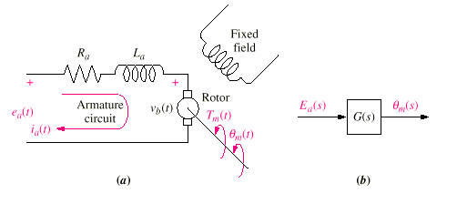Figure 3. DC motor (a) Schematic diagram. (b) Block diagram.

The governing differential equation of the model are derived from the equivalent circuit diagram of the DC motor from the given figure.

In a rotating circuit called armature, when a current carrying conductor cuts the magnetic field perpendicularly, torque ‘ $T_{m}$’ is developed. The developed torque is directly proportional to the flux and the armature current ‘ $i_{a}$’ of the motor.

$T_{m}\left(t\right)=K_{t}i_{a}\left(t\right)$ (1)

There is another phenomenon that occurs in the motor: A conductor moving at right angles to a magnetic field generates a voltage at the terminals of the conductor equal to **e = Blv,** where ‘**e’**is the voltage and ‘**v’**is the velocity of the conductor normal to the magnetic field and ‘**l’** is the length of the conductor. Since the current-carrying armature is rotating in a magnetic field, its voltage is proportional to speed.

$v_{b}\left(t\right)=K_{b}\frac{dθ_{m}(t)}{dt}$ (2)

$K_{b}$ is the back emf constant.

Apply KVL in the schematic diagram of the figure 1(a) then we got the relation between the armature current, applied armature voltage and back emf voltage as follows.

$e_{a}\left(t\right)=R_{a}i_{a}\left(t\right)+L_{a}\frac{di_{a}\left(t\right)}{dt}{+v}_{b}\left(t\right)$ (3)

Consider the mechanical loading on a motor.

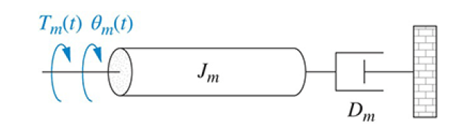

Figure. 4 Mechanical load on a motor

Figure 2 shows a typical equivalent mechanical loading on a motor. ***Jm***is the equivalent inertia at the armature and includes both the armature inertia and the load inertia reflected to the armature. ***Dm***is the equivalent viscous damping at the armature and includes both the armature viscous damping and the load viscous damping reflected to the armature. From Figure 2 we can write the governing equation.

$T_{m}\left(t\right)+T_{L}\left(t\right)=J_{m}\frac{d^{2}θ_{m}\left(t\right)}{dt^{2}}{+D}_{m}\frac{dθ_{m}(t)}{dt}$ (4)

**State space representation of DC Motor-:** From the equation no (4) it is clear that the motor angular position ‘ $θ_{m}$’, angular velocity $ω_{m}=$ $\frac{dθ_{m}}{dt}$ and torque developed by the motor ‘ $T_{m}$’ is controlled by varying the applied armature voltage which is supply voltage ‘ $e_{a}$’ and ‘ $T_{L}$’ is load torque.

Therefore, we choose the motor torque, angular position and angular velocity as the three state variables to obtain the state space representation.

The state space representation is-

Inputs variables are-

$x_{1}\left(t\right)= T_{m}\left(t\right)$ (5)

$\dot{x_{1}}\left(t\right)= \dot{T_{m}}\left(t\right)=\frac{dT_{m}(t)}{dt}$ (6)

$x_{2}\left(t\right)= θ_{m}\left(t\right)$ (7)

$\dot{x_{2}}\left(t\right)= \dot{θ_{m}}\left(t\right)=\frac{dθ_{m}(t)}{dt}=ω_{m}\left(t\right)=x_{3}\left(t\right)$ (8)

$\dot{x_{3}}\left(t\right)= \dot{ω_{m}}\left(t\right)=\frac{d^{2}θ_{m}\left(t\right)}{dt^{2}}$ (9)

Outputs variables are-

$y_{1}\left(t\right)= T_{m}\left(t\right)=x_{1}\left(t\right)$ (10)

$y_{2}\left(t\right)= θ_{m}\left(t\right)=x_{2}\left(t\right)$ (11)

$y_{3}\left(t\right)= ω_{m}\left(t\right)={\frac{dθ_{m}(t)}{dt}=x}_{3}\left(t\right)$ (12)

From equation (1) we can write that

$$i_{a}\left(t\right)=\frac{T_{m}\left(t\right)}{K_{t}}$$

Put the $i_{a}\left(t\right)$ values in the equation no (3) then equation (3) become-

$e_{a}\left(t\right)=R_{a}\left(\frac{T_{m}\left(t\right)}{K_{t}}\right)+\left(\frac{L_{a}}{K_{t}}\right)\frac{dT_{m}\left(t\right)}{dt}{+K}_{b}\frac{dθ_{m}(t)}{dt}$ (13)

Writing equation (13) in terms of state variables

$e_{a}\left(t\right)=R_{a}x_{1}\left(t\right)+\left(\frac{L_{a}}{K_{t}}\right)\dot{x_{1}}\left(t\right){+K}_{b}x_{3}\left(t\right)$ (14)

Rewriting the above equation (14) we get the first state equation as follows

$\dot{x_{1}}\left(t\right)=\left(-\frac{R_{a}}{L_{a}}\right)x_{1}\left(t\right)+\left(\frac{K_{t}}{L_{a}}\right)e_{a}\left(t\right)+\left(-\frac{{K_{t}K}_{b}}{L_{a}}\right)x_{3}\left(t\right)$ (15)

Similarly substituting state variables in the equation (4) we get,

$x_{1}\left(t\right)-T_{L}\left(t\right)=J_{m}{\dot{x_{3}}\left(t\right)+D}_{m}x_{3}\left(t\right)$ (16)

Rewriting the above equation, we get the second and third state representation as follows

$\dot{x_{3}}\left(t\right)=\left(\frac{1}{J_{m}}\right)x_{1}\left(t\right)-\left(\frac{D_{m}}{J_{m}}\right)x_{3}\left(t\right)-\left(\frac{1}{J_{m}}\right)T_{L}\left(t\right)$ (17)

The state space representation of the DC motor is represented as follows.

As we know the standard state equations and output equations are

$\dot{x}$ (t)=Ax(t)+Bu(t)

$$y\left(t\right)=Cx(t)$$

Using this concept our state space representation are as follows

+ (18)

$\left[\begin{matrix}y_{1}(t) \\ y_{2}(t) \\ y_{3}(t)\end{matrix}\right]=\left[\begin{matrix}1 & 0 & 0 \\ 0 & 1 & 0 \\ 0 & 0 & 1\end{matrix}\right]\left[\begin{matrix}T_{m}(t) \\ θ_{m}(t) \\ ω_{m}(t)\end{matrix}\right]$ (19)

**Matlab code-**

clc;

clear all;

close all;

%% parameter values are taken from “Simulation and modelling of a DC motor used in a mobile robot” title paper

Ra=0.007; %% Armature resistance in ohm

La=0.000090; %% Armature inductance in henary

Kt=0.050; %% Torque constant

Kb=0.050; %% Back emfconstant

Ja=130*10^-7;%% Moment of inertia in kg m^2

Da=0.0160; %% Rotor viscous damping in Nm/rad/second

JL=3200; %% Load side inertia in kg-m^2

DL=800; %% Load side viscous damping in Nm/rad/second

Ts=0.003; %% Sampling time in second

TL=0; %% Load torue

Ea=48; %% Supply voltage in volt

N1=1; %% No of teeth on primary shaft side

N2=156; %% No of teeth on secondary load side

N=(N1/N2)^2; %% Equivalent gear ratio

Dm=Da+(N*DL); %% Equivalent viscous damping in Nm/rad/sec

Jm=Ja+(N*JL); %% Equivalent inertia in kg-m^2

Ac=[-(Ra/La) 0 (-(Kt*Kb)/La);

0 0 1;

(1/Ja) 0 -(Da/Ja)]; %% System matrix

Bc=[(Kt/La) 0;

0 0;

0 -(1/Ja)]; %% Input matrix

Cc=[ 1 0 0;

0 1 0;

0 0 1]; %% Output matrix

Dc=[0]; %% Transmission matrix

motor_sys_continuous=ss(Ac,Bc,Cc,Dc);

motor_sys_discrete=c2d(motor_sys_continuous, Ts);

[Ad,Bd,Cd,Dd]=ssdata(motor_sys_discrete);

x(:,1)=[0;0;0];

for k=1:1:30;

u(:,k)=[Ea,TL];

x(:,k+1)=Ad*x(:,k)+Bd*u(:,k);

y(:,k)=Cd*x(:,k);

Ia(k)=y(1,k)/Kt;

T(k)=k*Ts;

end

plot(T,u(1,:),'--r','linewidth', 2);

hold on

plot(T,u(2,:),'-.r','linewidth', 2);

hold on

plot(T,y(1,:),'-.ok','linewidth', 2);

hold on

plot(T,y(2,:),'-sk','linewidth', 2);

hold on

plot(T,y(3,:),'-dk','linewidth', 2);

hold on

plot(T,Ia,'-b','linewidth', 2);

grid on

xlabel('Time(second)');

ylabel('Amplitude');

legend('input voltage (v)','Load torque (Nm)','Armature current (A)','Angular velocity (RPM)','Motor torue (Nm)');

title('Step responce of a DC motor');



Figure. 5 Step response of DC motor

**Future work-:**

Plot and perform the MATLAB results with all these four conditions in open loop and close loop system response.

**References-:**

**[1]** Dorf and Bishop, Modern Control Systems, 9th Ed., Prentice-Hall, Inc. 2001

**[2]** Norman S. Nise, “Control system engineering”, 8thEdition, Wiley, 2020.

**[3]** Internet material regarding state space approach for DC material.